Desk Reference Title
Month Day, Year

Introduction
A desk reference is written to provide clear/concise instructions on how to accomplish a work process.
Please follow the guidelines below when writing a desk reference:
- Use a numbered outline structure vs. lengthy paragraphs.
- Provide step by step instructions.
- Short explanations are fine if they will help the person completing the task understand why the step is important.
- Always include a hyperlink to sites you reference.
- Attach examples in your desk reference if appropriate. [Number List 2] – Built-in spacing
(6 point after each item). If numbers do not restart, right click on the number and select “restart” or “continue” numbering.
  - To attach an example: Insert, Object
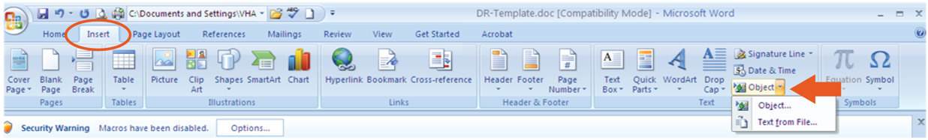
  - Select the Create from File Tab, and browse to your example, check the Display as icon box, select OK.
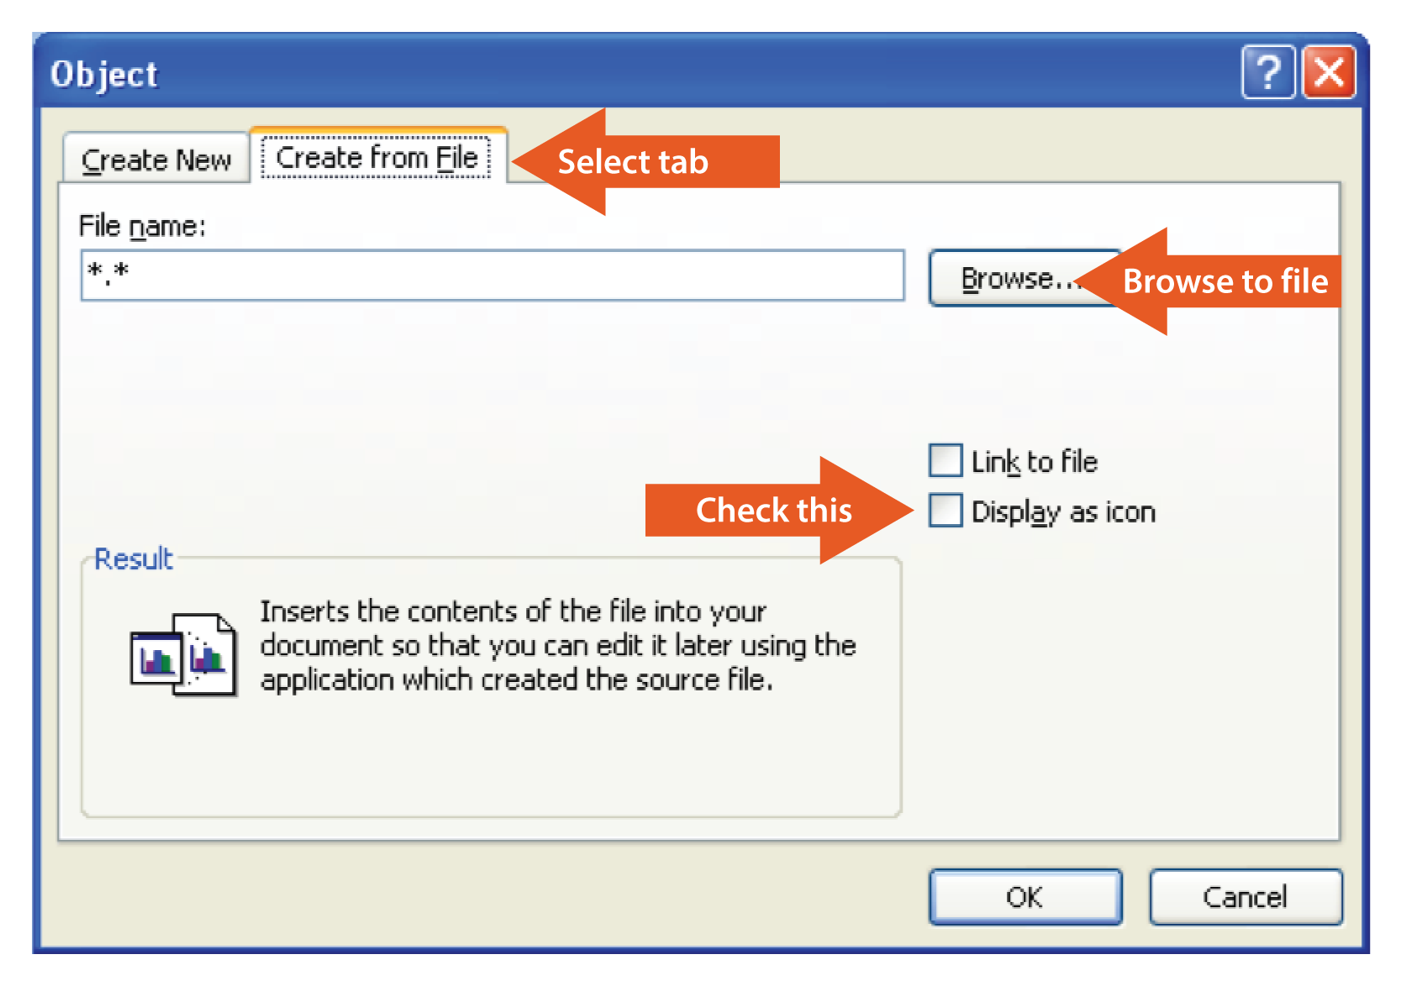
  - Your example will look like this in your desk reference. It will be easily accessible, but it will not lengthen the desk reference significantly.
Note: Embedded media content cannot be accessed by keyboard-only or assistive technology users. If necessary to embed media content, you must apply descriptive alt-text to the content (right click and select “Add Alt Text”) and provide an alternative file or website link for download. For more information on this topic, please consult the U.S. Department of Veterans Affairs Section 508 website.
- Use screen prints to show the user how to complete the steps (see example above).
  - Use arrows or other inserted shapes to direct the user to the button/tab/check-box at a glance.
  - If you are sure the reader is very familiar with the program, this level of instruction may not be required.
- Include a name of the person responsible for maintaining this document and recertification date. See example below:
  - Responsibility: Julie Schuck
  - Recertification: Bi-annual review required on 5/1/2013
- Save the document with a descriptive title in the following format if you are placing it in the OES Shared Docs folder: DR-Template-for-writing-deskreference

